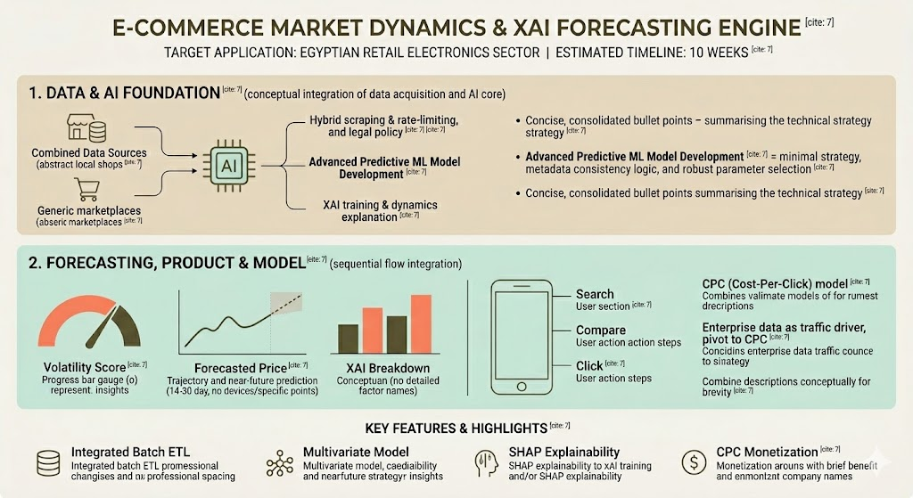

E-Commerce Market Dynamics & XAI Forecasting Engine
Target Application: The Egyptian Retail Electronics Sector
Estimated Timeline: X Weeks
03.02.2026
─
Mohannad Zahra 185
Abdlerhman Wael 172
Mohammed Hessen 174
XX XX XX

Overview
The Egyptian retail electronics market experiences extreme price volatility driven by multivariate economic factors (inflation, currency fluctuations) and decentralized inventory. Egyptian consumers lack data-driven tools to combat price asymmetry. This project proposes a scalable, AI-driven web platform that aggregates cross-retailer pricing via a hybrid dual-ingestion ETL pipeline. Utilizing sophisticated forecasting and Explainable AI (SHAP), the platform provides consumers with interactive price comparisons, time-series price predictions, transparent "Price Volatility Scores", and automated alerts, facilitating efficient purchasing decisions in a volatile market.

Goals
- Academic Goal: Successfully implement and validate multivariate forecasting architectures (combining SARIMAX with LightGBM) and SHAP to demystify complex pricing dynamics within highly volatile economic environments.
- Engineering Goal: Architect a robust, asynchronous ETL pipeline using Python and FastAPI. This pipeline will execute 12-to-24-hour batch scraping cycles using a hybrid extraction strategy (custom scrapers for local retailers, commercial APIs for enterprise platforms).
- Product (MVP) Goal: Deliver a functional, consumer-facing React web application that provides users with actionable market insights and validates the B2C Cost-Per-Click (CPC) monetization model.

Project Objectives & Scope
Hybrid Data Engineering: Construct a robust ETL pipeline targeting marketplaces (Amazon Egypt, Noon) via commercial scrapers, and local Egyptian retailers (e.g., B.TECH, 2B) via custom-engineered, rate-limited scrapers.
Algorithmic Transparency: Implement SHAP (Explainable AI) to translate complex market fluctuations (lagged prices, macroeconomic indicators) into user-friendly visual insights.
Real-World Application: Deliver an MVP capable of live inference on Track B (live Egyptian) data, driving user engagement through interactive comparisons and predictive alerts.

Specifications
Functional Requirements:
- Product Discovery & Interactive Comparison: Users can search for specific electronics. Upon clicking a model, a unified dashboard displays current pricing and availability across all tracked retailers, providing direct outbound links for immediate cross-comparison.
- Time Series Price Forecasting: Utilizing the trained SARIMAX/LightGBM model, the platform will display a 14-to-30-day projected price trajectory chart, empowering users to anticipate near-future market movements (e.g., predicting a price drop after an upcoming electronics release).
- The "Volatility Score" Metric: The system will calculate and display a normalized metric (e.g., 0-100 scale) indicating the current price instability of a product. A "High Volatility" score warns a user that the price is actively fluctuating and they should wait, while a "Low Volatility" score indicates a stable buying window.
- XAI Dashboard: The UI must render a SHAP-powered visual breakdown explaining why the Volatility Score and Forecast are what they are. It will highlight specific driving features (e.g., "Recent EGP fluctuation drove 40% of this price increase" or "Seasonal Back-to-School demand is currently inflating the price").
- Alert System: Users can set target prices; the system dispatches automated notifications when batch-scraped prices drop below thresholds.

Non-Functional Requirements:
- Batch Processing & Performance: To ensure sub-3-second UI rendering, the system will rely on a database populated by 12/24-hour background ETL cycles rather than scraping dynamically on user search.
- Legal & Ethical Scraping: Strict adherence to rate limits and reliance on commercial proxy networks for enterprise targets to prevent IP blacklisting and maintain legal compliance.
- Architecture Stack: React.js (Frontend), Python/FastAPI (Backend), LightGBM/SARIMAX/SHAP (Machine Learning), and a robust database for time-stamped, multivariate data.

Proposed Methodology: The Dual-Track Approach
Track A (Algorithmic Validation): The ML and XAI pipelines will be initially trained and validated on an open-source retail dataset from a macroeconomically volatile proxy market (e.g., Turkey or Argentina). This proves the model's soundness in high-inflation environments.
Track B (Live Data Engineering): Concurrently, the hybrid scraping engine extracts live Egyptian market data. Once data volume is sufficient, the pre-built ML pipeline will be pointed at Track B for live MVP inference.

Risk Assessment & Mitigation

Risk Category | Identified Risk | Mitigation Strategy
Technical | Anti-bot measures blocking scrapers. | Hybrid Scraping: Utilize commercial scrapers for Amazon/Noon; custom scrapers only on local retailers.
Academic | Inadequate feature space for XAI. | Multivariate Model: Shift to LightGBM/SARIMAX architecture incorporating macroeconomic indicators and lagged variables.
Business | Terms of Service (ToS) violations. | CPC Strategy: Treat enterprise data as a traffic driver; pivot initial monetization to a Cost-Per-Click (CPC) model with local Egyptian retailers.

Project Milestones & Timeline (X Weeks)
Weeks 1-3 (Infrastructure): Database schema finalized; hybrid ETL pipeline deployed running on 12/24h batches.
Weeks 4-6 (Validation): FastAPI endpoints established. Track A (volatile proxy dataset) processed through LightGBM/SHAP architectures; forecasting models tuned.
Weeks 7-8 (MVP Assembly): React frontend developed. Track B (live Egyptian data) actively populating the comparison dashboard, forecast charts, and alert system.
Weeks 9-10 (Polish & Defense): End-to-end system stress testing, UI/UX refinement, and comprehensive technical report completion.

